Annual Procurement Report and Annual Report on Procurement Activity in Scotland

Guidance and Template

This document provides information on putting together an annual procurement report, including reference to what must be included as required by the Procurement Reform (Scotland) Act 2014. This guidance should be read in conjunction with this Act and the Guidance under the Procurement Reform (Scotland) Act 2014.

Annual Procurement Report

Annual procurement reports allow an organisation to record and publicise its performance and achievements in delivering its procurement strategy. It provides an opportunity for organisations to demonstrate to their stakeholders that their procurement spend is being used to best effect to achieve:

- Better public services;
- Social, economic and environmental outcomes in their area; and,
- A range of local and national policies e.g. those relating to tackling inequality and meeting climate change obligations.
As well as providing information on how organisations consult and engage with stakeholders, alongside the procurement strategy, the annual procurement report will be a key document in enabling informed engagement with them e.g. external or internal clients, strategic partners, etc.

Where an organisation is required to prepare a procurement strategy, or review an existing one, it must also publish an annual procurement report. A public organisation which has an estimated total value of regulated procurement spend of £5 million or more (excluding VAT) in a financial year is required to prepare and publish a procurement strategy. More information on procurement strategies is provided in the Procurement Strategy Guidance and Template.

The procurement strategy and annual procurement report are now part of the reporting landscape for organisations who meet this spend threshold. Together, these measures generally support increased transparency and visibility of public procurement, and will help to embed relevant and proportionate sustainable procurement within Scottish public sector procurement, as illustrated overleaf:

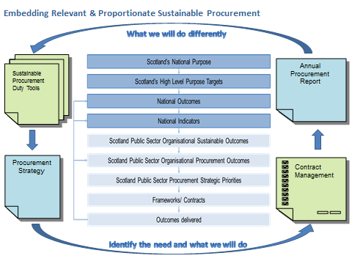

Section 18 of the Procurement Reform (Scotland) Act 2014 sets out the minimum content that an annual procurement report must include. The image below illustrates the minimum content that an organisation must provide in its procurement strategy and annual procurement.

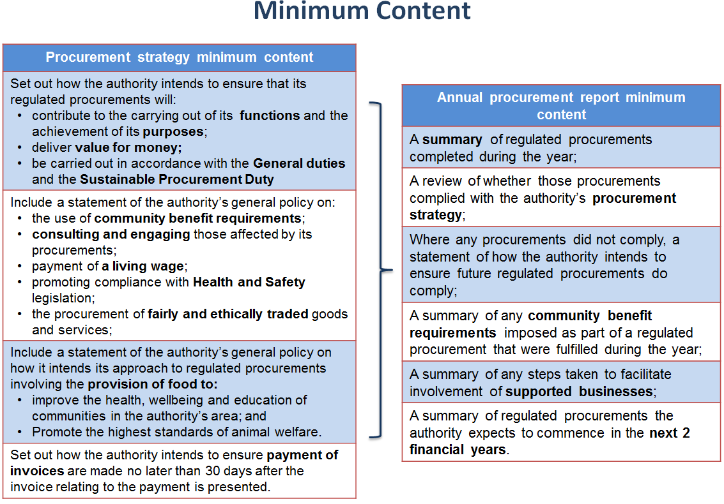

The annual procurement report should be relevant and proportionate to the size and spend of the organisation, providing transparency of its purchasing activities. The statutory guidance states that an annual procurement report must address all of the matters contained in an organisation’s procurement strategy. That is why the template focuses primarily on the minimum content required by the Act, and with some suggestions for other information.

The annual procurement report must be published as soon as reasonably practicable after the end of the financial year.

Publication of an annual report is to be in a way the organisation considers appropriate, but must include publication on the internet and should consider equality and accessibility issues.

More information on what must be included in the annual procurement report, including publication dates, can be found in section 2.6.2 of the Guidance under the Procurement Reform (Scotland) Act 2014.

Monitoring and Reviewing

Organisations are responsible for ensuring their procurement activities comply with relevant legislation and that the decisions it takes, in the context of its procurement activity, are in accordance with the legislation and its own strategic objectives.

Elements of the effectiveness of the procurement strategy and annual procurement report will be measured via the Procurement & Commercial Improvement Programme (PCIP). If your organisation is involved in the PCIP process, your organisation should recognise that while there are obviously relevant PCIP assessment questions e.g. 1.2 in Lite, and 1.3 for Medium and Full, your procurement strategy and subsequent annual procurement report will be intrinsically linked to many of the questions in the PCIP assessment. Although not a mandatory requirement of the Act, it is strongly recommended that you focus on these linkages when considering the PCIP and reporting processes.

An organisation should publish its report in a manner that allows its stakeholders to form a clear view of its performance.

Annual Report on Procurement Activity in Scotland

Scottish Ministers will prepare an annual report on procurement activity in Scotland as soon as reasonably practicable after the end of each financial year. As a result procurement reporting in Scotland will now take place at several levels, as illustrated below:
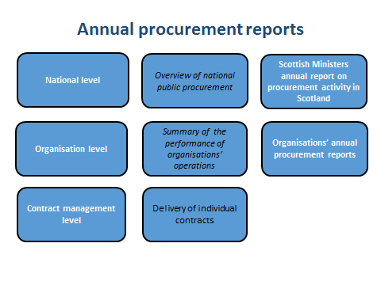
An annual procurement report is an opportunity for an organisation to demonstrate how its procurement activity delivers value for money, contributes to the achievement of its broader aims and objectives, and how it has delivered against those policies and commitments set out in its procurement strategy. Whilst it is recognised that there is no one size fits all approach - since an annual procurement report will reflect performance against that contracting authority’s procurement strategy – the Procurement Reform (Scotland) Act 2014 sets out what, as a minimum, each annual procurement report must contain.

The report by Scottish Ministers will be based on information contained within individual annual procurement reports and such other information that is considered appropriate. It is important therefore to ensure the minimum content that must be included in every annual procurement report is presented in a way that is consistent not only to inform the report by Scottish Ministers, but also because striving for consistency, where appropriate, in those things that must be included in every annual procurement report is helpful to the reader.

Annual Procurement Report Template

Section 18 of the Procurement Reform (Scotland) Act 2014 provides details of the minimum content that an annual procurement report must contain. The content is by no means limited to those items and other information to be included within an organisation’s annual procurement report will be informed by a number of considerations, such as the size and spend of the organisation and the scope of its procurement activity.

The information provided by organisations in their annual procurement reports will be included in high-level analysis undertaken by the Scottish Government. This high-level analysis is in preparation for the Scottish Ministers annual report on procurement activity in Scotland.

Whilst this template focuses primarily on the minimum content set out in the Act, providing further guidance on the level of detail that should be included, it also contains information relating to other content for consideration.

The sections included in this template are:

- Section 1 Summary of Regulated Procurements Completed – Required by the Act
- Section 2 Review of Regulated Procurement Compliance – Required by the Act
- Section 3 Community Benefit Summary – Required by the Act
- Section 4 Supported Businesses Summary – Required by the Act
- Section 5 Future Regulated Procurements Summary – Required by the Act
- Section 6 Other Content for Consideration
- Annex 1 Sustainable Procurement Duty

It is advisable for the organisation to include in their annual procurement report:

- an introduction/purpose section which sets the scene and allows the annual procurement report to evidence, in later sections, whether regulated procurements have complied with the published procurement strategy
- details of the annual procurement report owner (accountable officer/team) name, responsibilities and contact details.
- a glossary of terms in their annual procurement report to explain/define any unusual, difficult or specific words, terms or expressions, especially if they operate in a specialist field/market. The Procurement Journey contains a glossary of procurement specific terminology which could be utilised.
Please note that:

- this template is an example only and its format should be adapted to suit individual circumstances, however the minimum requirements listed in this template must be included in the organisation annual procurement report
- the term “organisation” used in this document also refers to: contracting authority; contracting entity; public body; public organisation
- the term “contract” used in this document includes all binding contracts e.g. includes framework agreements, mini competitions collaborative contracts, call offs

Section 1 – Summary of Regulated Procurements Completed

This section includes information that is required as a minimum by the Procurement Reform (Scotland) Act 2014.

Section 18(2) of the Procurement Reform (Scotland) Act 2014 requires organisations to include: “a summary of the regulated procurements that have been completed during the year covered by the report”

A regulated procurement is completed when the award notice is published or where the procurement process otherwise comes to an end. This includes contracts and framework agreements.

Why?
The principle of transparency requires an organisation to approach its public procurements in an open and inclusive manner.

Publishing a summary of regulated procurements completed will be helpful in demonstrating that the organisation is acting in a transparent manner and in highlighting its procurement activity during the course of the year.

How to Complete?
An organisation must provide a high-level summary of the regulated procurements it has completed within the timeframe covered by the annual procurement report, including information regarding any collaborative contracts let in cooperation with other organisations and Non Competitive Actions (NCAs)/an award without a competitive procurement process.

Quantitative Information:
An organisation should also include information on each individual regulated procurement completed during the reporting period. This can be attached as an annex to the annual report itself. This information should include:

- the date of award
- the name of the supplier
- the subject matter
- estimated value of the contract
- the start date
- the end date provided for in the contract (disregarding any option to extend the contract) or, where there is no date specified, a description of the circumstances in which the contract will end

The above information should already have been made publicly available through the organisation’s contracts register (via PCS or other published means). However, because contracts registers only show live contracts, it is not sufficient to merely include a link to the organisation’s contracts register in the annual procurement report or to assume that all required information is already included in the contracts register.

Section 2 – Review of Regulated Procurement Compliance

This section includes information that is required as a minimum by the Procurement Reform (Scotland) Act 2014.

Section 17 of the Procurement Reform (Scotland) Act 2014 makes it mandatory for regulated procurements to be carried out in accordance with the organisation’s procurement strategy. Section 18 (2) states that an annual procurement report must include “a review of whether those procurements complied with the authority’s procurement strategy” and “the extent to which any regulated procurements did not comply, and a statement detailing how the organisation will ensure that future regulated procurements do comply”.

Why?
Where the procurement strategy is a means to illustrate procurement’s place within an organisation and the importance of procurement to successful delivery of wider organisational objectives, the annual procurement report provides a chance to demonstrate how procurement has contributed to the achievement of those specific objectives and to the general duties in the Act that should have been reported in the published procurement strategy.

The legislation requires organisations carry out an assessment of how they have delivered against the objectives identified in the procurement strategy during the reporting period.

It is in organisations’ interest to carry out this review in a way which allows for the identification of where there is still scope for improvement. This will help the organisation in the task of reviewing its procurement strategy for the forthcoming period.

How to Complete?
In order to successfully complete this section of the annual procurement report, it is necessary for organisations to revisit their procurement strategies and the commitments, statements of general policy and milestones set out in these. It may also prove helpful to return to section 2.5 of the statutory guidance which sets out what the form and content requirements are of the procurement strategy.

Qualitative Information:
An organisation should include, for example: details of how its procurement activity achieved the policies set out in its procurement strategy; how these contributed to its wider organisational aims and objectives; and highlight any other positive impacts resulting from its procurement activity.

An organisation should include details of policies which were not met and how these can be better achieved in future procurements. Examples could include: providing details of new/amended internal governance procedures and/or processes or new/amended procurement tools to be used e.g. ICT.

Within its annual procurement report, an organisation should also include a brief statement detailing the methodology used to review its regulated procurements in relation to the requirements in section 15(5)(a)-(d) of the Act.
Further guidance on other content that must be included in an annual procurement report can be found on the following pages.

Specifically in the context of reviewing whether an organisation’s procurement processes complied with their policy statement on the payment of a living wage to those working on their contracts, organisations should consider the following:

- their approach to ensure their procurement processes delivered to the commitments made in their policy statement
- the scope of commitments to the Living Wage and fair work practices achieved by implementing their policy
- the benefits / outcomes
- the approach to contract monitoring to ensure outcomes are delivered

Quantitative Information:
To further evidence the qualitative information provided, an organisation should provide quantitative information. For example, number / type of regulated procurements which did and did not comply with the commitments in the strategy, and, in relation to payments of invoices, payment performance information.

Suggestions relating to how organisations may wish to demonstrate that they have complied with the sustainable procurement duty are available in Annex 1. These will complement the reporting in Section 3 (Community Benefits) and Section 4 (Supported Businesses).

Section 3 – Community Benefit Summary

This section includes information that is required as a minimum by the Procurement Reform (Scotland) Act 2014.

Section 18(2) of the Procurement Reform (Scotland) Act 2014 states that it is mandatory for an annual procurement report to include “a summary of any community benefit requirements imposed as part of a regulated procurement that were fulfilled during the year covered by the report”.

Why?
Scotland has a strong track record in delivering social and environmental benefits through its public procurement activity. Community benefit clauses provide a means of achieving sustainability in public contracts. They include targeted recruitment and training, small business and social enterprise development and community engagement.
This is an important element of the sustainable procurement duty and the steps taken by the organisation to include community benefit requirements where appropriate in regulated procurements, or set out reasons for not doing so, will be helpful to the organisation in demonstrating compliance with that duty.
While community benefits must be considered for all procurement processes at or above £4 million in value the sustainable procurement duty may result in the inclusion of community benefit requirements at lower thresholds. (The data gathered from the annual procurement report will help assess whether this threshold is at the correct level).

How to Complete?
Qualitative Information:
An organisation should explain how it has ensured that its regulated procurements complied with legislation and its general policy on community benefit requirements,
and make reference to the types of community benefit requirements that were fulfilled during the year covered by the report.

Quantitative Information:
The Statutory Guidance included as Annex A.2 Monitoring and Reporting, a table of suggested community benefit summary information. That table is based on research published in 2015 and the recommendations therein. The list of outputs is not exhaustive and organisations are therefore strongly encouraged to use that template as the basis of community benefits achieved.

Information should include community benefit requirements imposed as part of a regulated procurement that were delivered during the period covered by the report. This may include community benefits delivered within the reporting year on contracts placed prior to the reporting period.

Section 4 – Supported BusinessesSummary

This section includes information that is required as a minimum by the Procurement Reform (Scotland) Act 2014.

Section 18(2) of the Procurement Reform (Scotland) Act 2014 requires organisations to include “a summary of any steps taken to facilitate the involvement of supported businesses in regulated procurements during the year covered by the report”.

Why?
Supported Businesses make an important contribution to the Scottish economy, through the goods and services they deliver, but also by providing meaningful employment, training and social support for those who may otherwise be excluded from the workplace.

This is an important element of the sustainable procurement duty and the steps taken by the organisation to facilitate the involvement of supported businesses in regulated procurements will therefore be helpful to the organisation in demonstrating compliance with that duty.

How to Complete?
Qualitative Information:
Please provide a narrative on the steps taken to facilitate the involvement of supported businesses in regulated procurements during the year covered by the report. Examples of this may include:
- details of discussions held with supported businesses in the market analysis phase of commodity strategy development;
- the number of supported business suppliers in the period covered by the report
- details of engagement with existing supported businesses to help grow their commercial resilience
- plans to increase supported business spend/engagement

Quantitative Information:
- Regulated procurements placed with supported businesses during the period covered by the report.
- Total actual spend with supported businesses during the period covered by the report. This should include:
  - spend within the reporting year on contracts already placed;
  - spend through sub-contracting arrangements on contracts already placed.

Section 5 – Future Regulated Procurements Summary

This section includes information that is required as a minimum by the Procurement Reform (Scotland) Act 2014.

Section 18(2) of the Procurement Reform (Scotland) Act 2014 states it is mandatory that an annual procurement report must include “a summary of the regulated procurements the authority expects to commence in the next two financial years.”

Why?
Acting in a transparent and proportionate manner is an effective way by which an organisation can encourage competition and achieve better value for money in its procurements. It promotes wider participation in the public procurement process and this information will give notice to suppliers of future opportunities.

How to Complete?
Whilst it is acknowledged that at the time an organisation prepares its annual procurement report, it is unlikely to know what its precise requirements will be over the course of the next two financial years, it should be in a position to provide a brief forward plan of anticipated procurements, including planned contract extensions. The information provided should be relevant and proportionate to the spend of the organisation.

The information that must be provided for each individual regulated procurements projected to commence in the next two financial years:

- the subject matter
- whether it is a new, extended or re-let procurement
- the expected contract notice publication date
- expected award date
- expected start date
- the estimated value of the contract

Section 6 – Other Content for Consideration

Every organisation’s annual procurement report will differ as every organisation’s procurement strategy is unique. It is the responsibility of the organisation to ensure that its final published annual procurement report is relevant and proportionate, meeting all legal and internal governance requirements.

In addition to the elements required as a minimum by the Procurement Reform (Scotland) Act 2014, as detailed previously in this template, there are a number of other common elements which an organisation may wish to consider including in its annual procurement report. Some examples are shown below and over the page, but this is not an exhaustive list:

- Details of Contract and Supplier Management activities in place, and planned, and the benefits realised from these activities
- Other reporting duties e.g. Equality and Climate Change Reporting Duties
- Identification and management of risks & opportunities e.g. collaboration opportunities with procurement centres of expertise
- Approach to developing procurement capability and people, such as the number of procurement personnel, relevant professional qualifications and approach to elearning and development within the organisation.

The organisation may opt to include additional spend information such as:
- total spend for the period covered by the annual procurement report for: all procurements; by category A (national contracts), B (sectoral contracts) and C (local contracts), by specific project
- spend with SME’s
- percentage spend through collaborative contracts
and savings information such as:
- total targeted savings for regulated procurements for the period covered by the annual procurement report
- total delivered savings for regulated procurements for the period covered by the annual procurement report
- total targeted savings for the period covered by the annual procurement report split by category A, B and C
- total savings delivered in the period covered by the annual procurement report by category A, B and C
examples of other information which an organisation may consider to include are:
- total number of lotted contracts awarded and, for those not lotted, an explanation as to why not
- percentage of category C/frameworks in place covered by a commodity strategy
- number of light touch regime contracts placed during the period

Annex 1

Sustainable Procurement Duty

Specifically in the context of addressing organisations’ obligations under the Sustainable Procurement Duty, it should be kept in mind that the Scottish public sector approach to sustainable procurement is closely linked to the priorities set out in the National Performance Framework (NPF) and is underpinned by a range of sustainability indicators, outlined below. Organisations might find it helpful to refer to NPF outcomes and related indicators in their reports:

- Climate change (carbon and energy consumption, carbon in production, adaption, carbon in vehicle emissions);
- Materials (scarcity, security);
- Waste (production, reuse/recondition/remanufacture);
- Hazardous materials/emissions;
- Bio-security
- Bio-diversity (protection and enhancement);
- Heritage (protection and enhancement);
- Water (consumption and production);
- Employment (skills and training, SMEs/social enterprises/supported businesses – this element of compliance directly relates to the distinct reporting obligations in section 5 and 6 of this template);
- Communities;
- Security and crime (impact and improvement);
- Fair and ethical trading (working conditions, conflict materials);
- Equality (protected characteristics);
- Fair work.
Further details on these indicators, including definitions, are available from the sustainability test.

Organisations are able to add any local priorities to the tools when they are employing the approach outlined in the statutory guidance, so may have other elements they need to report on.

By using the tools as advocated in the statutory guidance, organisations should be able to identify and pursue opportunities associated with individual procurement projects.

This approach should allow organisations to meet reporting obligations under the Climate Change (Scotland) Act 2009 and the Equality Act 2010 (Specific Duties) (Scotland) Regulations 2012.

