Procurement Journey
Care and Support Services Contract Type, Duration and Transitional Arrangements

Care and Support Services Contract Type, Duration and Transitional Arrangements

Determining the Type and Duration of the Contract

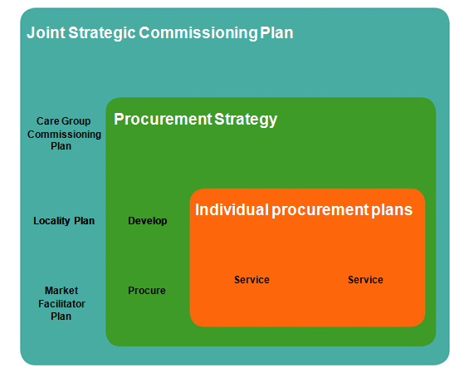
An organisation’s policies and procedures for the procurement for care and support services should identify an appropriate range of contracting mechanisms and provide a rationale for selecting different mechanisms, based on best value, the need for service continuity and desired outcomes for individuals. Individual procurement plans (see below) should describe the type and duration of the proposed contract or framework agreement.

An organisation should determine the most appropriate contractual mechanism on a case-by-case basis and ensure that suitable contracts are in place with all providers delivering care and support services.

Contracts will typically comprise a number of documents:

  - the general terms and conditions which set out the obligations of the organisation and service provider; and

  - schedules, including the service specification, which set out the specific details of the services to be provided and the arrangements for their provision.

Contracts for care and support services have traditionally required specific activities to be undertaken at specific times, with payment contingent upon inputs (resources) and outputs (service levels). The success of a contract has been determined by the extent to which the service provider has delivered the prescribed service. Contracts should be outcome-based. Outcome-based contracting is designed to shift the focus from activities to results. The success of a contract is determined by the extent to which the service provider can demonstrate progress towards achieving the specified outcomes. An outcome-based contract should include:

  - the outcomes to be achieved – these must be realistic and take account of external factors which might impede progress;
  - clear performance expectations and measures;
  - key milestones which indicate progress and dates for achieving these; and
  - monitoring arrangements which ensure performance is being achieved.

In addition, all contracts should be:

  - clear, concise and written in plain English;
  - complete and unambiguous – contracts should set out the obligations of the parties in a way that does not allow for differing interpretations of what is required;
  - comprehensive and consistent – there should be no contradiction of requirements or approach (an organisation should ensure that all the documents which comprise the contract support the achievement of the required outcomes);
  - flexible – contract conditions should be adjusted to take account of provider requirements for example, frequency of payment to smaller providers to maintain cash flow (but care must be exercised if conditions are amended after a competition as this would have the effect of distorting that competition);
  - detail shared risk – contracts should seek to reduce both the impact and the likelihood of risk within acceptable levels and to define what each party must do to make this possible; and
  - contain appropriate equalities and human rights clauses.

Contracts should also make appropriate provision for dealing with poor performance.

Contract duration

Unlike framework agreements there are no explicit limits in public procurement law on the duration of a contract, although excessively long contracts may be open to challenge on the grounds that they are designed to distort markets/competition. Contract duration should be determined on a case-by-case basis, taking into account the organisation’s requirements and the needs of the people who use the services; contracts should be subject to a review of service delivery at appropriate intervals.

An organisation may decide to award contracts of longer duration, where necessary, to ensure continuity of service for people who use the services. It is possible to frame contracts in a way which would allow the service provider to continue to provide a service to a person who uses the service for an extended period. For example, it may be appropriate to specify that the service provider should (subject to satisfactory performance) provide continuous support for that individual for as long as support is required.

Decisions about contract duration should also include consideration of the importance of having a skilled, engaged and stable workforce in social care. Frequent re-tendering may have adverse implications for staff morale and conditions of service and can lead to the loss of highly motivated staff. Local authorities may, where appropriate, take a three-year (or longer) approach to funding, offering service providers the necessary stability

to retain and train their staff and to plan for service development. It is, however, recognised that short-term funding may be appropriate in certain circumstances in order to encourage innovation in service delivery and respond to the changing needs of local communities.

It is also possible to provide that a contract will (subject to satisfactory performance) be extended by a certain period of years. Any option to extend the contract must be made clear at the outset in the contract notice. An organisation should consider whether the circumstances make it appropriate to award a contract of longer duration (rather than providing an extension option), thereby offering itself and service providers greater certainty.

It might be appropriate to include price adjustment clauses in service contracts of longer duration, for example over two years. Price adjustments clauses determine the parameters for adjusting price (upwards or downwards) during the term of the contract. The inclusion by an organisation of ‘no-fault’ termination, or break, clauses and successor body clauses in contracts of longer duration can provide flexibility in the event of a change in the organisation’s requirements.

Clauses relating to transitional arrangements

An organisation should include clauses which specify the arrangements that will apply in the event that a service is transferred to a different service provider, including lead-in, exit and handover clauses. For example, consideration should be given to identifying the requirements on the incumbent service provider to transfer information such as care plans to the new provider.

An organisation should also include a clause requiring the incumbent service provider to provide information about staff, conditions and costs to potential service providers during a procurement exercise. This allows a potential service provider to assess the staffing and financial implications of TUPE transfers prior to submitting its tender.

Determining the transitional arrangements that will apply

An organisation should determine the transitional arrangements that will apply when a new service is established or if an existing service transfers to a different service provider. As part of the planning process, it should address:

- the timescale and arrangements for the service transfer;

- how it will communicate the outcome of the procurement exercise and the transitional arrangements to people who use the services and their carers, service providers and relevant staff within their own organisation (including assessment and care management staff);

- what information will be provided to people who use the services and their carers about SDS, including direct payments and arrangements for dealing with applications; and

additional support arrangements for people who use the services and their carers during the transition period.

A service provider also has a legal obligation to notify people who use services about care service cancellation.

An organisation may have legal obligations under the TUPE Regulations where it is outsourcing a service or bringing a service back in-house, in which case it should seek legal advice on the application of the Regulations to the particular circumstances. In all cases, organisations should consider the potential impact of staff transfers under the TUPE Regulations:

  - on continuity of support to people who use services and their carers;
  - on the cost of delivering the service; and
  - on the affected workforce.

It should also consider what action they will need to take to facilitate the exchange of information between service providers or the transfer of staff should the TUPE Regulations apply.

