Examples of Payment Performance Evidence

1. UK Government Published Payment Practice Reports
2. Accounts Payable Report
3. Payment Performance Statement Signed by External Auditor
4. Credit Score / Credit Report Provider
5. Accounts Payable Ratio

1. UK Government Published Payment Practice Reports

Link: Search for published payment practice reports (check-payment-practices.service.gov.uk)

- Free, accessible, up to date
- Suppliers meeting specific threshold requirements must publish to this site however suppliers can publish voluntary.

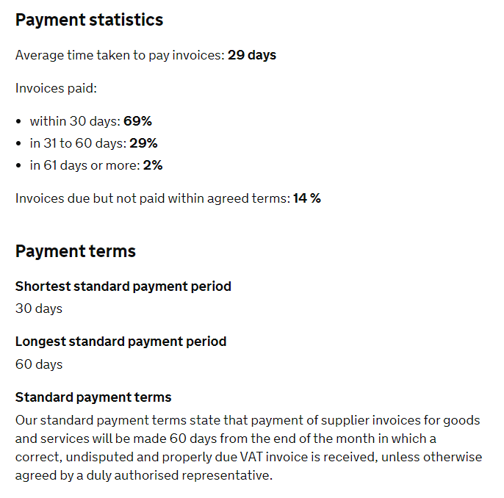
2. Accounts Payable Report

Below is an example of a SG AP report detailing payment performance for a specific time period:

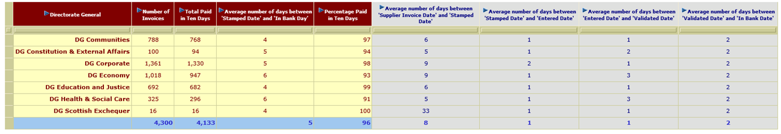
- Any AP report detailing the “invoice receipt date” and “In Bank Date/Invoice Paid Date” could be used to evidence payment performance
- Accessible, easy to use & up to date

3. Payment Performance Statement Signed by External Auditor

A statement on payment performance signed by an external auditor could be used as evidence. The statement must contain the declaration that “the supplier pays X% of invoices in line with their X day payment terms”.

4. Credit Score / Credit Report Provider

A number of suppliers provide a similar service such as Equifax, Experien & Dun & Bradstreet. The example below is an extract from Creditsafe. Points to note:

- A calculation may be needed to dermine the average payment performace percentage
- The data is not 100% accurate as it is based on payment data which is shared by the credit report provider partners/suppliers
- This is a paid service

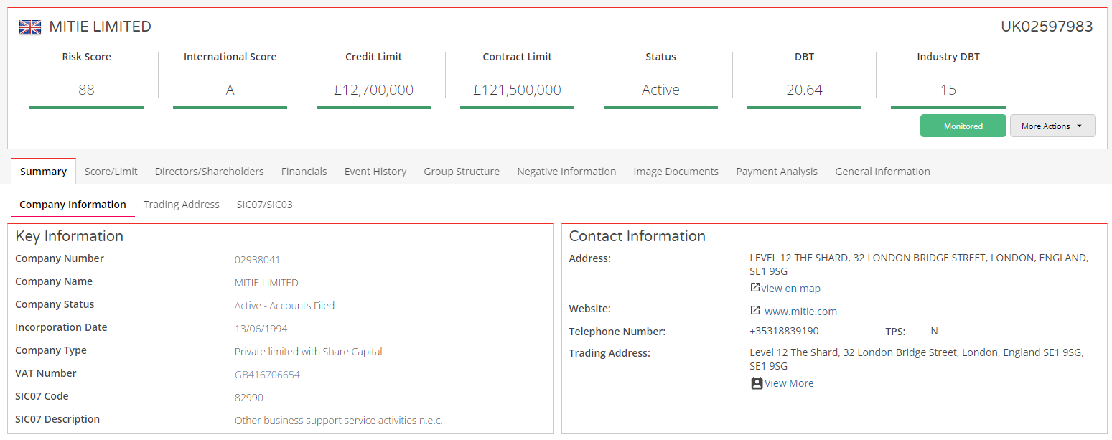

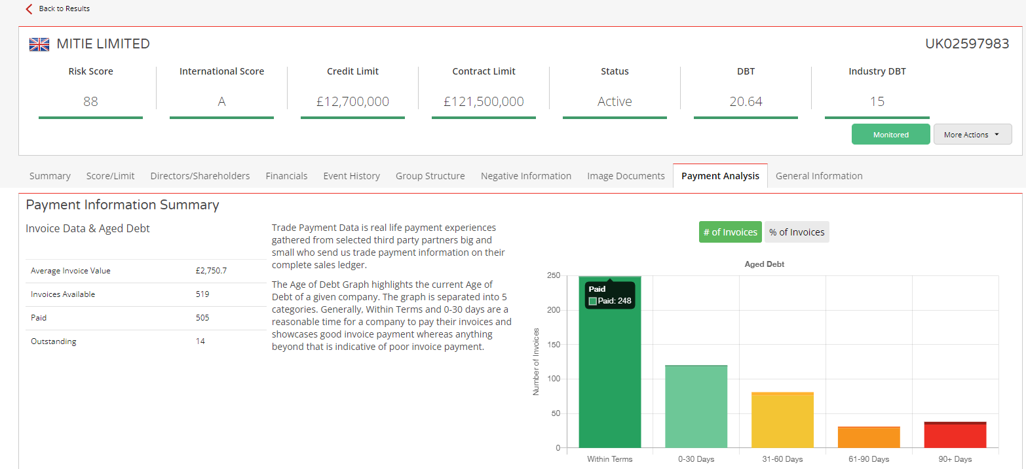

5. Accounts Payable Ratio

- Possibly use alongside other methods above as verification
- May be out of date depending on when the accounts were filed and any extenuating circumstances at time of filing
- Only a snapshot value for the time of the filing

- Payables turnover ratio=
(Cost of Sales (Supplier Purchases) / Accounts Payable (Total Liabilities))

- Accounts Payable Turnover in Days=
(365/Payable turnover ratio)

- Example: Companies House reports filed for Mitie Ltd which are freely available. Using their filed accounts up to 31 March 2021:

Payables turnover ratio = Cost of Sales (533,250)/Total Liabilities (119,184) = 4.47
Accounts Payable Turnover = 365/4.47 = 81 days

