Examples of Payment Performance Evidence

1. UK Government Published Payment Practice Reports
2. Accounts Payable Report
3. Payment Performance Statement Signed by External Auditor
4. Credit Score / Credit Report Provider
5. Accounts Payable Ratio

1. UK Government Published Payment Practice Reports

Link: Search for published payment practice reports (check-payment-practices.service.gov.uk)

- Free, accessible, up to date
- Suppliers meeting specific threshold requirements must publish to this site however suppliers can also publish voluntary.

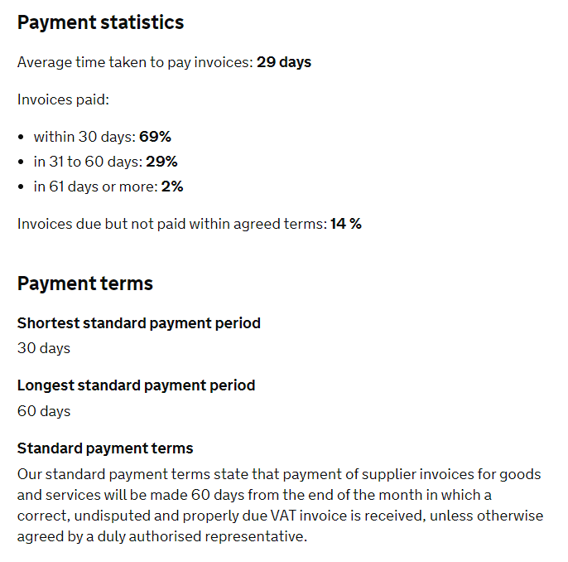
2. Accounts Payable Report

Below is an example of an AP report detailing payment performance for a specific time period:

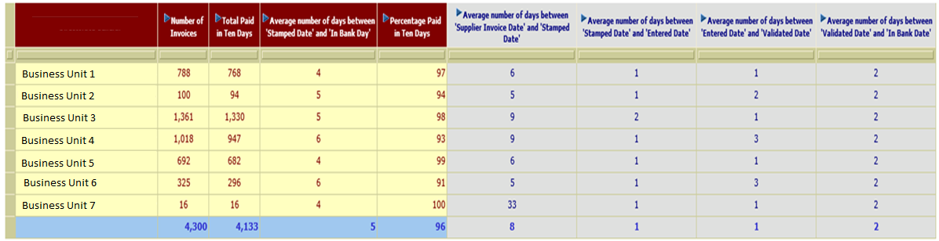

- Any AP report detailing the “invoice receipt date” and “In Bank Date/Invoice Paid Date” could be used to evidence payment performance
- Accessible, easy to use & up to date

3. Payment Performance Statement Signed by External Auditor

A statement on payment performance signed by an external auditor could be used as evidence. The statement must contain the declaration that “the supplier pays X% of invoices in line with their X day payment terms”.

4. Credit Score / Credit Report Provider

A number of suppliers provide a similar service such as Equifax, Experien & Dun & Bradstreet. The example below is an extract from Creditsafe. Points to note:

- A calculation may be needed to dermine the average payment performace percentage
- The data is not 100% accurate as it is based on payment data which is shared by the credit report provider partners/suppliers
- This is a paid service

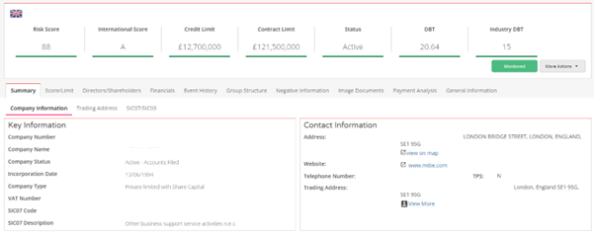

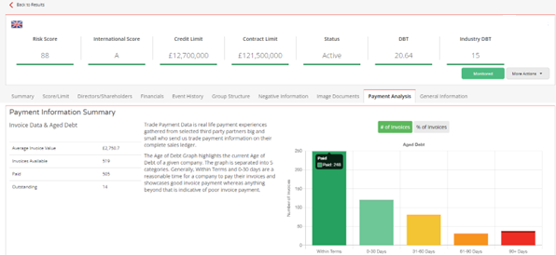

5. Accounts Payable Ratio

- Possibly use alongside other methods above as verification
- May be out of date depending on when the accounts were filed and any doesn’t take into account any extenuating circumstances at time of filing
- Only a snapshot value for the time of the filing

- Payables turnover ratio=
(Cost of Sales (Supplier Purchases) / Accounts Payable (Total Liabilities))

- Accounts Payable Turnover in Days=
(365/Payable turnover ratio)

- Example: Companies House reports filed for “Supplier X” Ltd which are freely available. Using their filed accounts up to 31 March 2021:

Payables turnover ratio = Cost of Sales (533,250)/Total Liabilities (119,184) = 4.47
Accounts Payable Turnover = 365/4.47 = 81 days

