Procurement Journey
Specific Considerations & Rules for Care and Support Contracts

Specific Considerations & Rules for Care and Support Contracts

Guidance on Contract Renewal and Direct Award without Competition

An organisation should analyse the benefits and risks to people who use services, and also to service delivery, of advertising the requirement and awarding the contract or framework agreement by competition. For existing services, this will require consideration, through consultation with people who use services and their carers, of the impact that any change in service provision or provider will have on:

  - people who use services and their carers;

  - continuity of care;

  - the quality of the service and the outcomes delivered;

  - the cost of the service;

  - the market; and

  - the workforce.

This analysis may suggest that, where an organisation is satisfied with the quality of a service and that best value is being achieved, the existing supplier / service provider should continue to deliver the service. If an organisation’s contract with the existing supplier / service provider includes an extension option that is within scope, the contract may be extended for the specified period. In the absence of an extension option, any decision by an organisation to renew (or ‘roll forward’) its contract with the existing supplier / service provider must be compliant with public procurement legislation. Legal advice should always be sought in respect of any procurement decisions.

Alternatively, the analysis may suggest that the requirement should not be advertised at the current time and that a staged approach should instead be adopted. If an organisation decides to adopt a different timetable for advertising the requirement, it should describe this in relevant procurement documents and set out how it intends to move towards competition in the future.

Summary of the rules that apply to care and support contracts at different thresholds

€750,000 | Must be advertised in OJEU and the light touch provisions in
and above | The Public Contracts (Scotland) Regulations 2015 apply
£50,000 - | May award without | May choose to seek offers: in
€750,000 | seeking offers, but | which case all provisions of the
 | should consider the | Procurement Reform (Scotland) Act
 | TFEU fundamental | 2014 apply
 | principles where
 | relevant. For contracts
Below |  | Non-regulated procurement
 | over £50,000, a contract
£50,000 | award notice must be
 | published on PCS
 | and certain other
 | rules apply
 | (see paragraph 8.12 of Guidance on the Procurement of Care and Support Services 2016 (Best-Practice).

Risk of legal challenge for breach of the procurement rules

A public body should assess the risk of legal challenge if it decides not to advertise the requirement and proceeds to award the contract or framework agreement without competition. A legal challenge may have serious implications for procurement activity and future service delivery. For example, for a ‘light-touch’ contract with a value of at least €750,000, if a court grants an ineffectiveness order together with damages, legal costs and/or compensation, this may divert monies from service provision and may cause significant disruption and uncertainty to people who use services. Also, standstill rules apply to care and support contracts of that value. The relevant legislation is part 3 of the Public Contracts (Scotland) Regulations 2015.

Application of legal remedies to contracts and framework agreements services covered under the ‘light-touch’ regime

The award of a contract or framework agreement for one of these services may be challenged on the basis that a public body has failed to ensure publication of the contract opportunity on the OJEU and follow a procedure sufficient to ensure observance of the TFEU fundamental principles. In relation to a contract or framework agreement worth at least €750,000 such a challenge would be pursued as a commercial action.

Specific rules for care and support contracts between £50,000 and €750,000 – award with advertising

For contracts or framework agreements with a value of £50,000 or more, but less than €750,000, an organisation should decide, on a case-by-case basis, whether or not to seek offers in relation to the proposed contract.

The flowchart at the end of this document provides some illustration of the sort of things that might be considered by an organisation when deciding whether to seek offers for contracts of this value. A number of factors may influence this decision, as explained below, but are not limited to:

  - the estimated value of the contract;

  - the application of the procurement rules, procurement policy and benefits and risks to people who use services and service delivery;

  - application of local financial regulations and standing orders; and

  - the specifics of the sector concerned (for example, the size and structure of the market and commercial practices).

Where an organisation chooses to seek offers in relation to a contract, then as with all contracts with a value of £50,000 or more, it must be advertised on the Public Contracts Scotland (PCS) website. All of the provisions of
the Act will apply in that case.

Specific rules for care and support contracts between £50,000 and €750,000 – award without advertising

Where an organisation decides to renew an existing contract, or to award a new contract without competition, it should ensure that:

  - its decision is based on sound and objective business reasons and that this is fully documented;

  - its decision not to award the contract or framework agreement by competition is permissible (see threshold diagram below) and compliant with the public procurement Regulations and the TFEU fundamental principles;

  - its decision is consistent with local financial regulations and standing orders and local policy and procedures for the procurement for care and support services;

  - it is able to demonstrate that best value has been achieved; and

  - the decision is subject to regular review. For example, a decision not to advertise and tender a contract because of its low value will need to be reviewed should the total sum to be paid under that contract increase.

For contracts of this value, an organisation may choose to award care or support contracts, or framework agreements, without seeking offers in relation to the proposed contract. This is consistent with the provisions of section 12 of the Act and this best-practice guidance should be read together with that. Under the Act, there are some provisions that still apply when an organisation chooses to award without advertising. These are:

  - Section 23(2) of the Act: An organisation must publicise a contract award notice on PCS;

  - Section 27 and Section 28 of the Act: An organisation must consider whether any of the mandatory exclusion grounds referred to in The Procurement (Scotland) Regulations 2016 apply in respect of the potential contractor/service provider; and

  - Section 35 of the Act: An organisation must keep and maintain a register of contracts (a ‘contracts register’).

In addition to these minimum requirements, a public body, when not seeking offers in relation to a proposed contract, should also consider, where applicable, the general duties (section 8 of the Act); technical specifications (section 30 of the Act); and charges for participation in the procurement process (section 31 of the Act).

Specific rules for Care and Support contracts below £50,000

Care and support contracts, or framework agreements, with a value below £50,000 are not regulated under the Act. As a matter of best practice a public body should however consider following a procurement process that is proportionate to the value of the contract.

Light-touch regime

Procurement Officers should be aware that there are some other services covered by the ‘light-touch’ regime that are not health or social care. Schedule 3 of the Public Contract (Scotland) Regulations 2015 also describes those services. The ‘light-touch’ EU rules also apply to these other services for contracts above the threshold (i.e. above €750,000). For below that threshold any procurement of these services is regulated by the Act.

FLOWCHART TO HELP DECISION MAKING FOR THE CONTINUATION OF

AN EXISTING SERVICE

- Analyse individual needs and intended outcomes to determine the type of service required and evaluate the existing arrangements for delivering the service.

- Involve people who use services and carers in defining their needs and desired outcomes and get their views on service improvement and continuity.

- Review information from people who use services and carers, contract management and service review, regulatory bodies and commissioning strategies to evaluate existing arrangements against best value principles.

- Assess the needs for improvement and service continuity.

- Consider available resources.
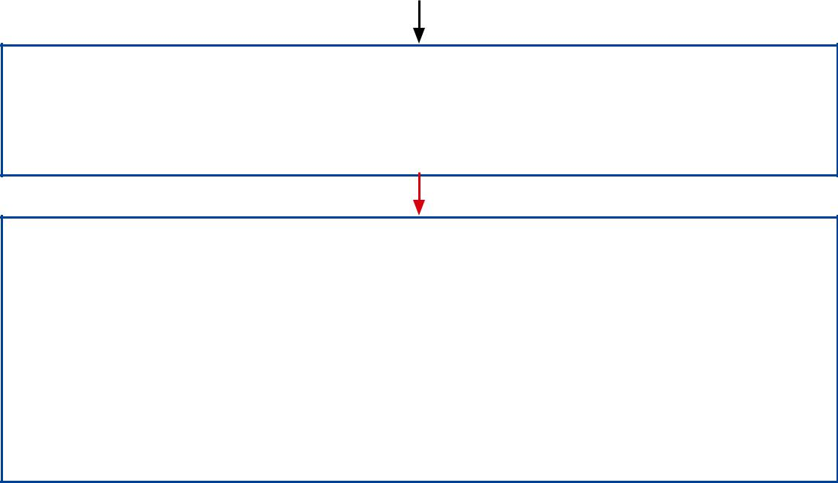

2. Consider the options for delivering the service.

- Should the service be provided by means of another arrangement, for example in house?

- Consider whether the TFEU fundamental principles and relevant legislation may require the contract to be advertised and awarded by competition.

- Is it possible to demonstrate that the contract is of no interest to service providers located in other member states?

- Is the total sum to be paid under the contract so low that service providers located in other Member States would not be interested in the contract?

- Is the service of such a specialised nature that no-cross border market of suitable service providers exists?

- Do regulations and standing orders allow the contract to be awarded without competition.

- Does analysis of the benefits and risks to service users and service delivery suggest that the contract should be renewed without competition.

- Does consideration of the impact that a change in service provision or provider will have on people who use services and carers, continuity or service, regulatory requirements, the quality and cost of the service, the market and the workforce suggest that the contract should be renewed without competition?

- A public body will want to consider the answers to all of these types of questions – and any other relevant considerations on a case-by-case basis – before reaching a decision about whether it needs to compete, or direct award,
a health or social care services contract.

There is no discretion for a public body to directly award health or social care contracts that are equal to, or greater than, the EU-regulated threshold of €750,000 and which are regulated by The Public Contracts (Scotland) Regulations 2015. See paragraph 8.8 for more details about the rules that apply at that level. A contract notice is required in all cases except where the circumstances described in regulation 33 of The Public Contracts (Scotland) Regulations 2015

