Procurement Journey

Supplier Cost Drivers

Labour | Overheads | Materials | Transportation
- Wage  - NI  - Insurances  - Pension contribution  - Sick/Holiday pay  - Maternity/Paternity pay  - Training  - Travel & Subsistence | - Utilities  - Property costs e.g. offices, warehousing  - Rent/Rates  - Consumables  - Sundries  - Head Office charge  - Car Fleet  - R & D  - Functional support e.g. IT, HR, Fin, Proc, PR, Acc Mgt  - Hospitality  - Refrigeration (specialist)  - Quality Assurance & control | - Raw Materials  - Work in Progress  - Finished Goods  - Rework/ Quality cost  - R & D  - Inventory  - Storage  - Picking Costs | - Vehicles  - Fuel  - Maintenance  - Distribution Centres  - Software e.g. route planning/sat nav.  - Shipping – rail, road, air, sea  - Port storage  - Import/export duties  - Insurances
Supplier Cost Drivers : Checklist

Supplier Cost Drivers Example

- Cost Component  - (Material, Order processing, Sub-contract, Transport, Overheads… | - % of Piece Price  - (Estimate, market, supplier and existing analysis | - Source of Data | - Data Confidence (Low, Medium, High)
- Total

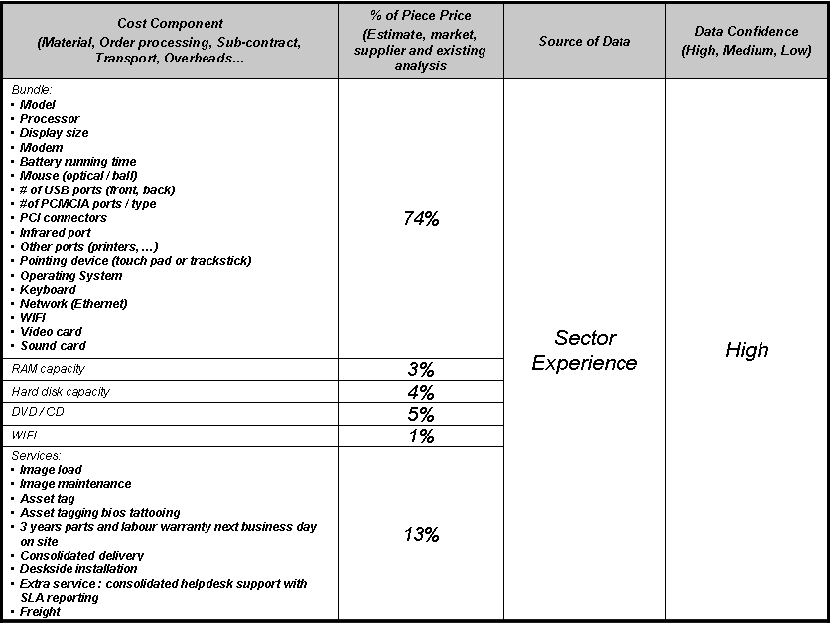

Suppliers Cost Drivers – Sources of Information.

