**Procurement Journey**

**UIG Example, Template and Membership**

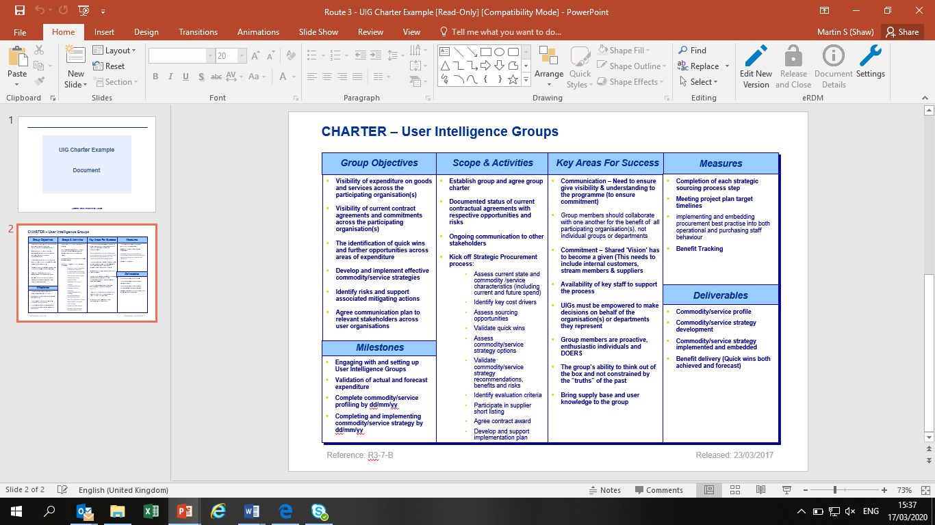

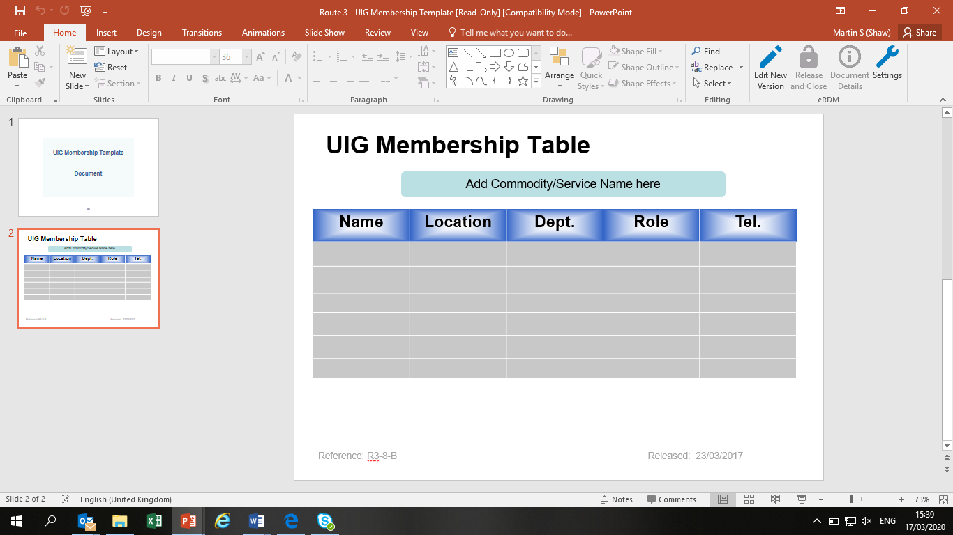

Group Objectives

Scope & Activities

Key Areas For Success

Measures

Milestones

Deliverables